**Fabric CNN Lab activity handout**

**File preparation:**

1. Open Google Colab and load the Fabric_AOI.ipynb
2. Import npy files into Google Colab
3. Import the required functions by running the first cell:

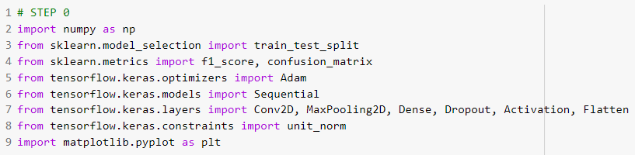

**Main activity:**

1. Load, preprocess, and split the data into training, validation, and testing

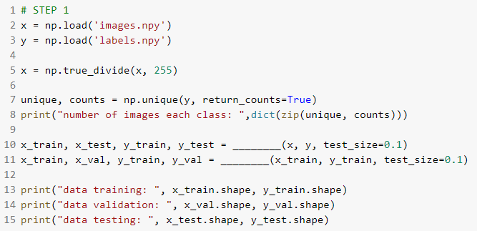

1. Build and compile the model

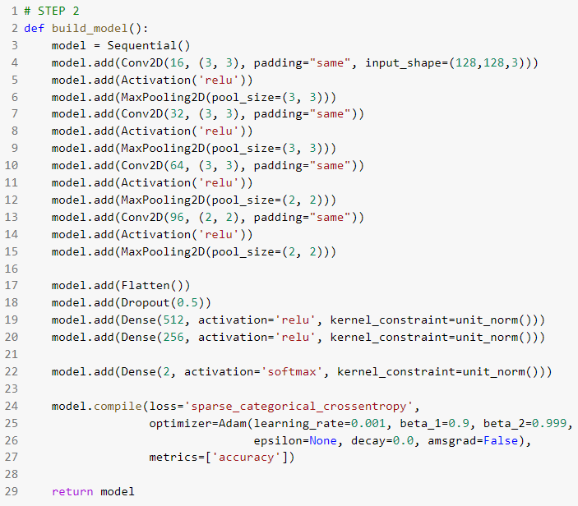

1. Train the model

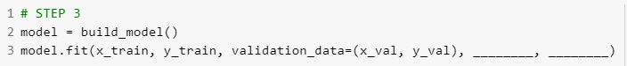

1. Calculate F1-score based on argmax class selection

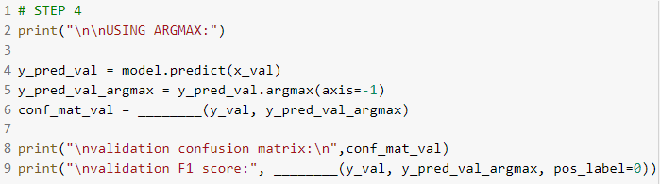

1. Calculate the F1-scores in multiple threshold values

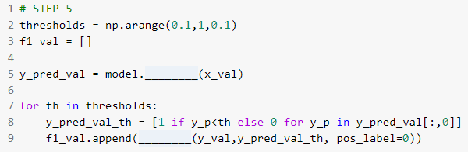

1. Select the best validation F1-score and show the F1 results and plots

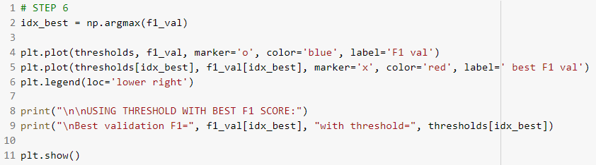

1. Compare the testing result

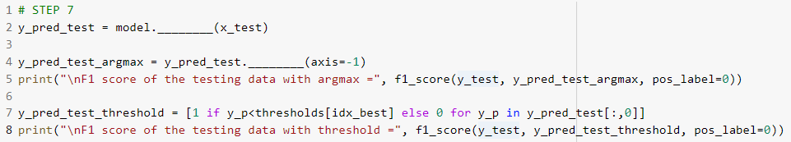

**Please create a report to briefly explain the results.**

**Submit the complete code (data can be excluded)**

**and the report before the specified time.**